NFCSD Art Educators May 18, 2020



Kindergarten & First-Grade Art Project
Supplies: Paper and any of these: pencils, crayons, colored pencils, markers, pen or paint made for young artists.

“April Showers Bring May Flowers”
Have you heard that saying? What do you think it means? Have you noticed any colorful flowers growing in your neighborhood? What colors are the flowers?

Famous artist, Claude Monet, said, “I must have flowers, always and always!”

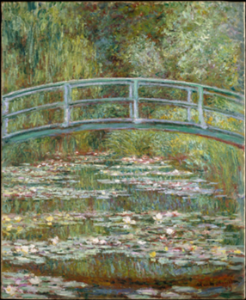
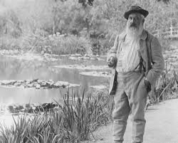
Here is Claude Monet standing in his garden in France. He was born in Paris, France in 1840 and lived to be 86 years old. Monet loved nature. When he was not painting, he was gardening.

Monet spent a lot of time painting his water lilies. He painted them at all times of day and in every season.
The title of the painting you see here is, “Japanese Bridge Over a Pond of Water Lilies.” Can you see the same bridge in both pictures?

*Draw your own flower garden. Think about the many different shapes and colors you could use. Don’t forget stems and leaves. Your flowers maybe short and close to the ground or tall and reaching toward the sky. Perhaps you will draw a flowering tree. Are insects or animals in your garden?

*Talk about your garden with someone. Describe what is going on in your picture. Do you have a favorite flower in your garden drawing? Why do you like it? Did you try something new? What happened? What would you do differently?

